**Master’s Degree in Computer Science**

**Academic year 2024/2025**

**INTERNET OF THINGS**

**AND SMART CITIES**

**Prof. Marco Giordani**

Written by Michael Amista’

A course offered by the School of Engineering (DEI) –

Master’s Degree in ICT for Internet and Multimedia

**Contents**

**Internet of Things and Smart Cities introduction** 3

**1. Internet of Things** 4

**1.1 Introduction** 4

**2. Smart Cities** 10

# **Internet of Things and Smart Cities introduction**

Course prefix for prof communications: IOTSC

From a customer perspective the IoT is the ability to use sensors and other devices to connect things in a way they work together. IoT finds its use in smart home, smart cities and industrial systems.

Obviously, the main issue when we talk about IoT is the **reliability** of the collected data and this is a big challenge in protecting our privacy, we will deal with that during the course. Another important problem is the **energy consumption**; many sensors and devices are not connected to energy. **Interoperability** is another problem: many manufacturers and many different devices 🡪 it is important to have a common standard to make different devices work together. Furthermore, depending on the number of devices, larger networks are created, and it is crucial that these networks are well handled.

The entire course is focused on IoT technology and its application to build smart cities.

Course schedule:

* Frontal lectures
* LAB experiences: it starts in November and there will be 3(+1) practical lab experiences. We will use Arduino (as a sensor) to send data to IoT LoRa gateway and we will see how to process those data to return an output.
* Guest lectures

The prof said that **slides (and attendance) are enough to pass the exam**.

The exam consists of two parts:

* **PART 1 (up to 28/33 points): Written test (mandatory)** that consists of both multiple-choice questions and open questions (even the guests lectures can be part of the written exam) with a duration of 1 hour and half.
* **PART 2 (up to 5 extra points): LAB assessment (optional)** which is “only” a replication of what done during lab lectures so if you follow the lab you should not have to study anything else to work on the assessment. The assessment can be submitted in December, before the written exam session. To submit the assessment, you must follow all lab lectures.

# **1. Internet of Things**

## **1.1 Introduction**

IoT is characterized by two fundamental concepts: **internet** and **things**.

The precursors of the modern Internet (ARPANET, CSNET, NSFNET) were resource sharing networks: computers were bulky and expensive, and researchers used nationwide connections to access them from far away. As personal computers became ubiquitous, and packet-switched traffic was ported to the ubiquitous telephone network, the Internet became the means for people all over the world to communicate with each other. In 1990, Tim Berners-Lee defines HTTP and HTML, leading to the explosion of the World Wide Web.

From interconnecting computers and people now IoT interconnects personal devices. The goal is to create a network, an architecture able to sustain all the different interconnected devices that shape the network. The basic idea is that interconnection needs to be invisible to users who do not have to do anything, everything is automatically, data are processed, and the users have an automatic response having so an autonomous network that works without human interaction.

WPAN is a technology specifically developed for IoT sensors. IoT sensors can use many technologies to communicate each other, from the nonspecific ones to more specific ones as WPAN.

We will see how IoT can decrease the costs and optimize operations, that’s why the IoT revenues are so high. Some statistics: the number of enterprises using IoT technologies is around 32%.

But what is IoT? We need a definition. There are a lot of definitions of what IoT is, all of them are correct but we will use a more formal definition than the ones that appear in the textbooks.

***Internet of things means connecting every thing.***

The key part of the definition of Internet of Things is the **Internet**, where Internet means IP protocol: No IP 🡪 No IoT. So, the course definition will be the following:

*“Internet of Things is a paradigm according to which every thing, real or*

*virtual, is assigned an IP(v6) address and can be reached (for example for*

*sensing or actuating purposes) via the standard Internet Protocol stack.”*

If you assign an IP address to a device, that device is actually part of the IoT network.

**An example of a “Smart” IoT system**

* One typical evening planning next working day...
* Tomorrow first office meeting at 8:30 am.
* Typical car trip in these days: 1 hour time.
* 45 minutes to wake up and get ready.
* I decide to set my alarm to wake up at 6:45 am.

What could (will) possibly go wrong?

* At 4:30 am it starts snowing
* Truck obstruction along the usual path
* Traffic congestion on alternative paths
* No parking at destination
* Bathroom cold when having shower
* Coffee cold when having breakfast
* Left my car keys at home when in garage
* Elevator busy when leaving my flat

**Leaving 10 min. late + 30 min. additional travel time 🡪 missed the meeting!**

An IoT approach to improve this scenario…

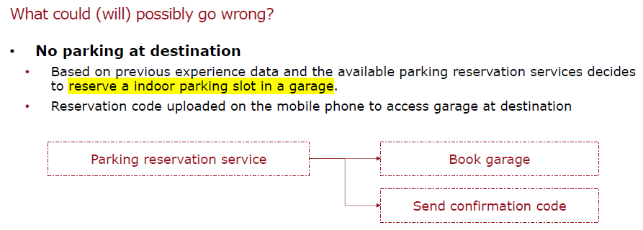

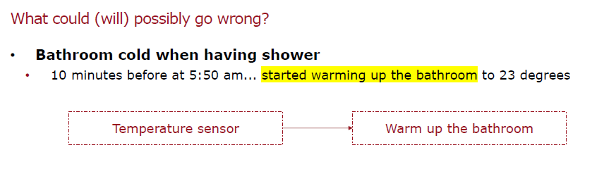

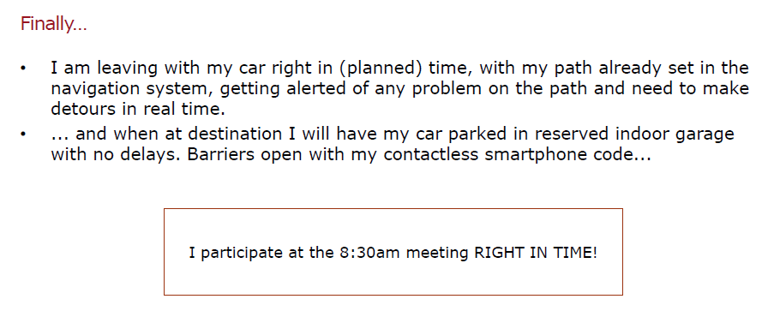

We want to have an integrated system made by smart things that make the life easier for the final consumer and so to take actions without human intervention.

**IoT high-level architecture**

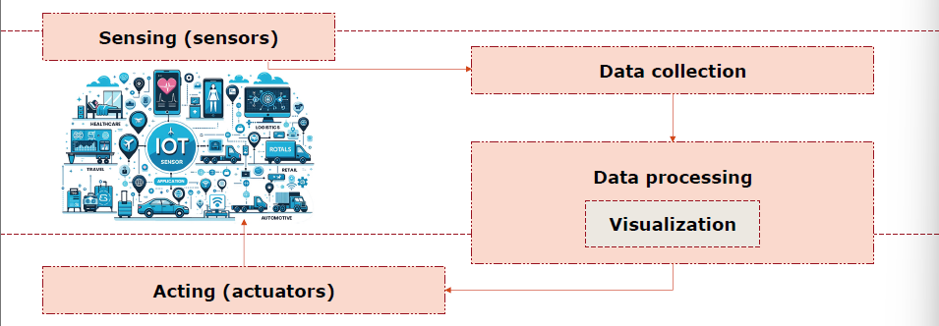

The heart of an IoT system are sensors that produce data to be consumed. Data are collected by a gateway and then they are processed (trigger actions) or only visualized (only to monitor the system making sure everything goes well). The actuator is another type of device that implements an action based on the result of data processing.

**Data collection**

* Sensors acting as a physical-cyber interface that monitors and reports states of some physical entity or device.
* Produce a digital representation suitable for use in the cyberspace.
* Relatively early in the process, metadata (a sort of appendix to real data, used to store other information such as the location) needs to be captured and used to annotate the data. In IoT systems, metadata generally describe the nature and context of data capture, such as the sensor type, its location, and in some cases structural relationships to other elements of the system.

**Processing and visualization**:

* Types of IoT data processing:
  + (Simple) control loop algorithms performed on the incoming data as they arrive.
  + Sophisticated forms of analytics and machine-learning algorithms based on past behaviours and observations of the system.
  + Common data processing steps:
    - Sampling, aliasing, quantization, saturation, hysteresis and non-linearities, calibration, error propagation, optimization and predictions (we’ll see…).
* In industrial and complex control systems, it is customary to visualize the system state and points of interest to system operators à digital twin / dashboard.
  + System state, notifications, alarms when faults or anomalous behaviors are detected.

**Acting**:

* Acting upon insights and predictions is the output and the ultimate purpose of deploying IoT systems.
* Common types of actions:
  + From simple remote actuation initiated by operators in response to visualized conditions in a basic monitoring configuration to automated guidance of control points.
* Actions can be implemented as direct actuation or indirectly, in the form of advice to system operators or optimizations resulting in adjustments to the manufacturing process.
* Identification of cause of failures and anomalous conditions followed by direct or indirect execution of the appropriate remediation actions.

**A more technical IoT architecture**

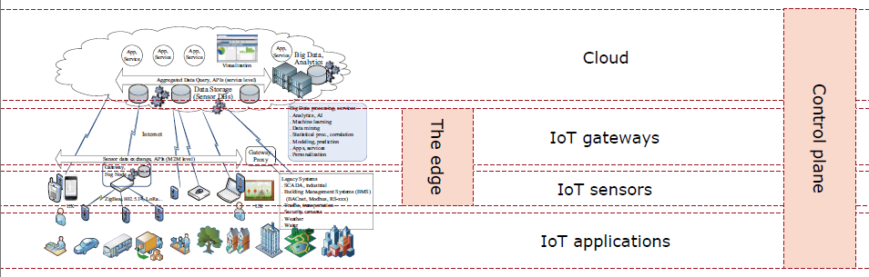

Let’s explore the different elements that shape this more technical architecture.

**IoT applications**

…

# **2. Smart Cities**

…